Given a**directed acyclic graph**, with n vertices numbered from 0 to n-1, and an array edges where edges[i] = [fromi, toi] represents a directed edge from node fromi to node toi.

Find *the smallest set of vertices from which all nodes in the graph are reachable*. It's guaranteed that a unique solution exists.

Notice that you can return the vertices in any order.

**Example 1:**

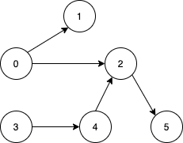

**Input:** n = 6, edges = [[0,1],[0,2],[2,5],[3,4],[4,2]]

**Output:** [0,3]

**Explanation:** It's not possible to reach all the nodes from a single vertex. From 0 we can reach [0,1,2,5]. From 3 we can reach [3,4,2,5]. So we output [0,3].

**Example 2:**

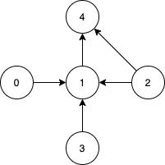

**Input:** n = 5, edges = [[0,1],[2,1],[3,1],[1,4],[2,4]]

**Output:** [0,2,3]

**Explanation:** Notice that vertices 0, 3 and 2 are not reachable from any other node, so we must include them. Also any of these vertices can reach nodes 1 and 4.

**Constraints:**

* 2 <= n <= 10^5
* 1 <= edges.length <= min(10^5, n * (n - 1) / 2)
* edges[i].length == 2
* 0 <= fromi, toi < n
* All pairs (fromi, toi) are distinct.